Lee Leopards Red Ribbon Week 2023
October 23rd – 27th, 2023
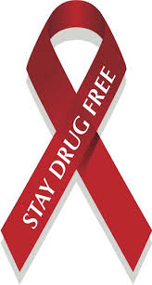
Proudly sponsored by Lee PTA

Since its beginning in 1985, the Red Ribbon has touched the lives of millions of people around the world. Parents and youth in communities across the country began wearing Red Ribbons as a symbol of their commitment to raise awareness of the destruction caused by drugs in America. Today, the Red Ribbon serves as a catalyst to mobilize communities to educate youth and encourage participation in drug prevention activities.

"Be Kind to Your Mind. Live Drug Free"
Show your school spirit and pride by participating in our themed dress days with meaningful messages.

Monday: “Take a stand to be Drug Free”  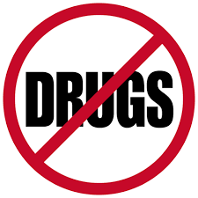 | Activity: Wear red  Reason: Get a bright start by making positive choices. Choose to be drug free and wear Red!
Tuesday: “Lei Off Drugs”  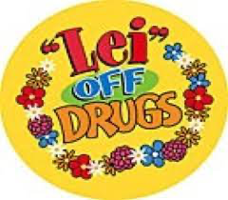 | Activity: Wear a Lei or Hawaiian Attire.  Reason: Don't be afraid to stand up for yourself and others. It just takes ONE person to make a positive impact.
Wednesday: “You have a bright future without Drugs”  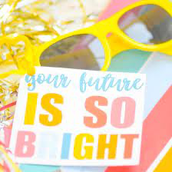 | Activity: Wear your Sunglasses.  Reason: With being drug free your future is so bright you must wear shades!
Thursday: “Team up Against Drugs”  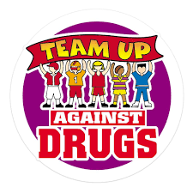 | Activity: Favorite Sports Team Gear.  Reason: You have a bright future that is drug free. Dress up as your favorite sports team or college!
Friday: "Our School Chooses to be Drug Free”  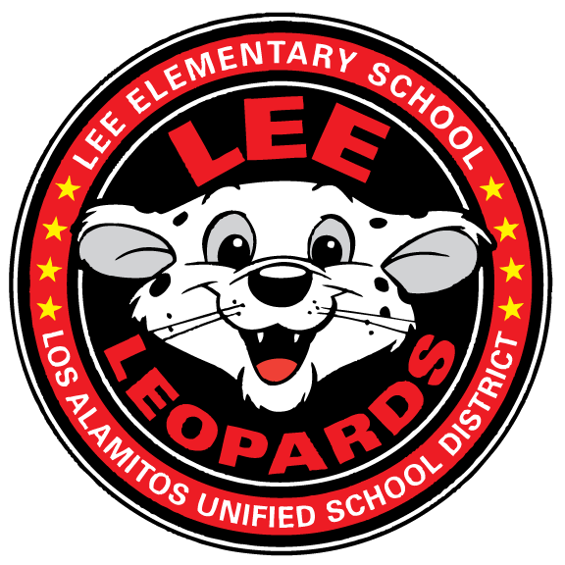 | Activity: Wear your Lee Gear!  Reason: Lee is proud to be Drug Free! Wear your Lee gear and show that our Leos are better than drugs!

